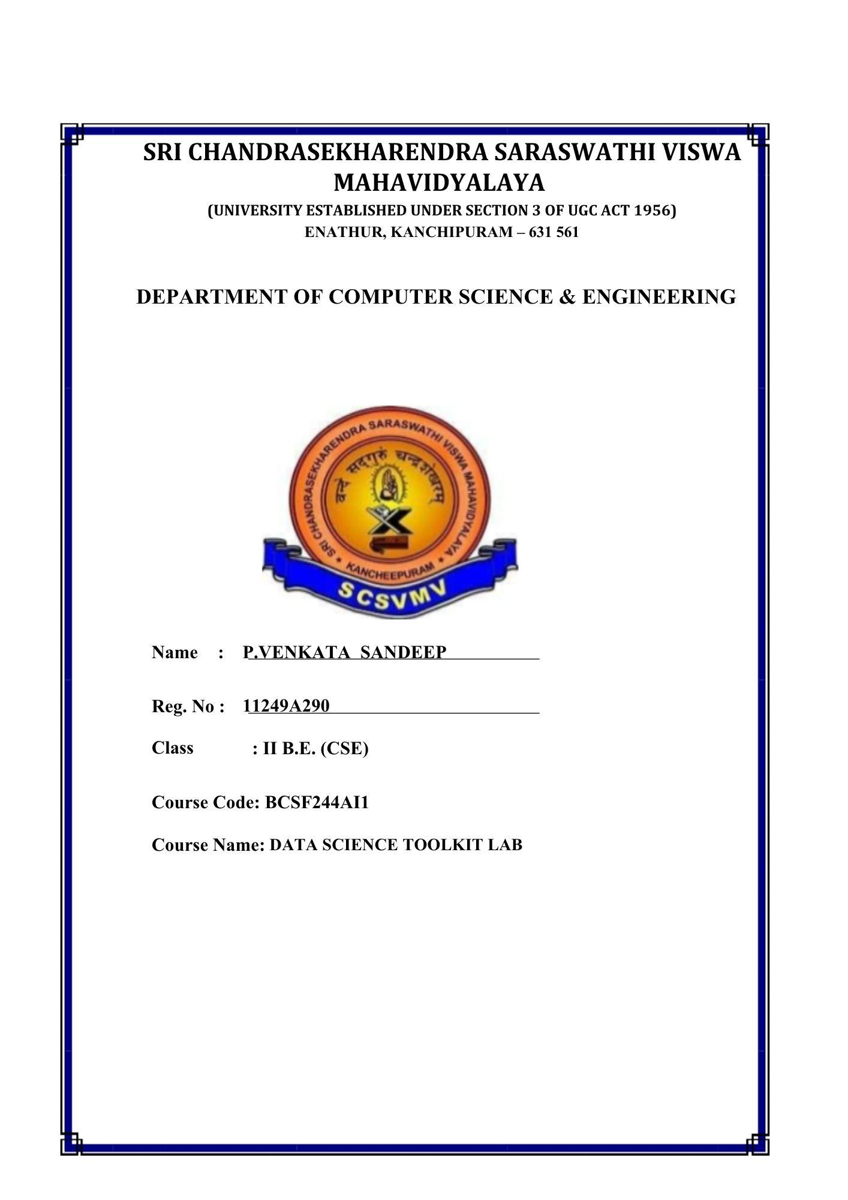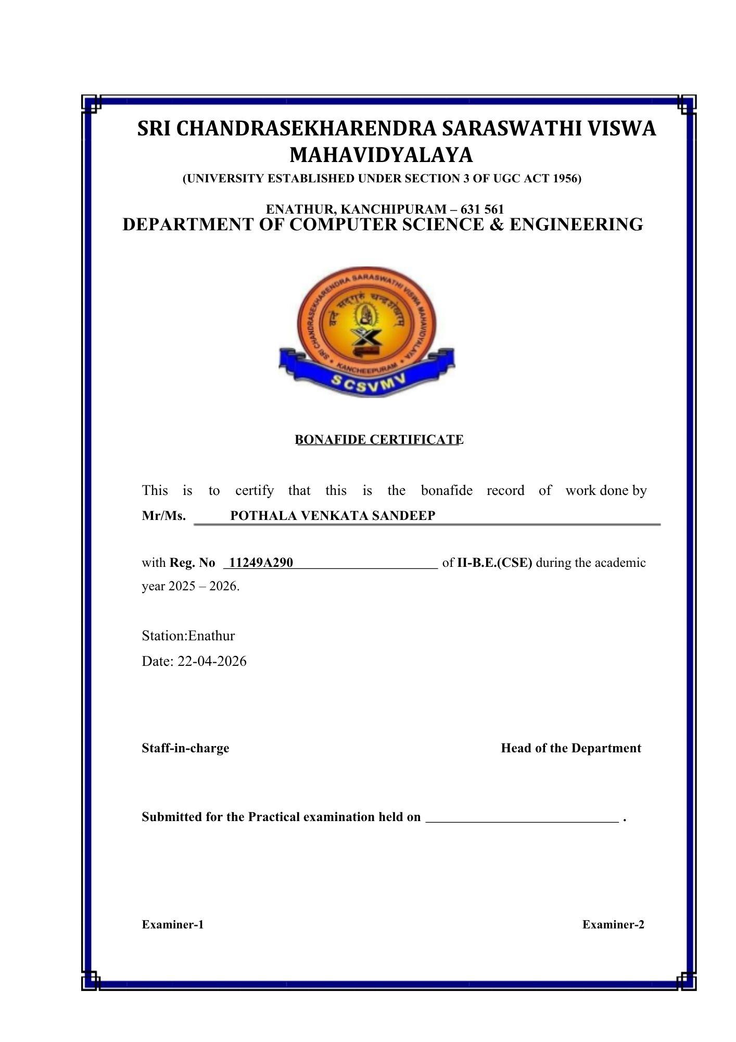
INDEX

SL.NO | Program Name | Page no | Date | Sign
1 | Introduction to Python Libraries- Numpy, Pandas, Matplotlib, Scikit | 1-8 | 05-02-26
2 | Perform Data exploration and preprocessing in Python | 9-10 | 12-02-26
3 | Implement regularised Linear regression | 11 | 19-02-26
4 | Implement Naive Bayes classifier for dataset stored as CSV file. | 12-13 | 05-03-26
5 | Implement regularized logistic regression | 14-17 | 05-03-26
6 | Build models using different Ensembling techniques. | 18 | 12-03-26
7 | Build models using Decision trees. | 19 | 12-03-26
8 | Build model using SVM with different kernels. | 20 | 02-04-26
9 | Implement K-NN algorithm to classify a dataset. | 21 | 02-04-26
10 | Build model to perform Clustering using K-means after applying PCA and  determining. | 22-24 | 02-04-26

Ex No:1 Date:05-02-26

Introduction to Python Libraries for Data Science
Aim:To learn basic Python libraries for Data Science (NumPy, Pandas,
Matplotlib, Scikit learn).

Program:

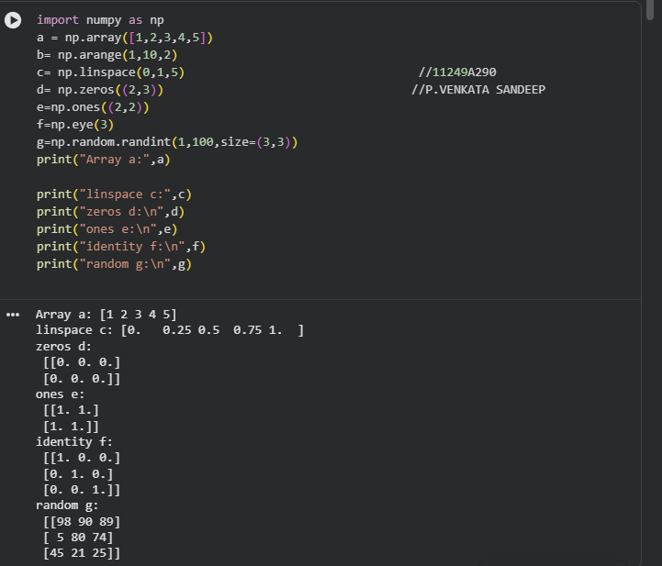

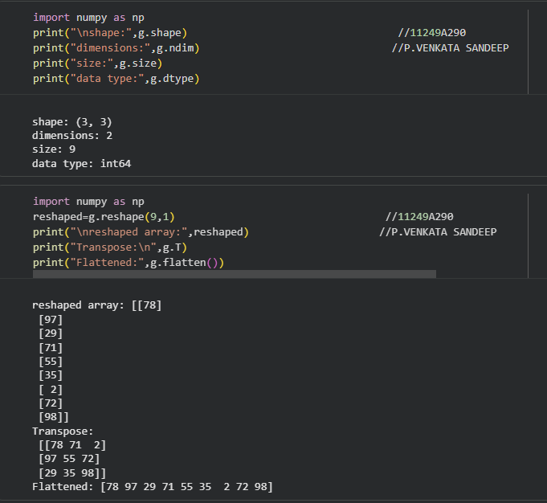

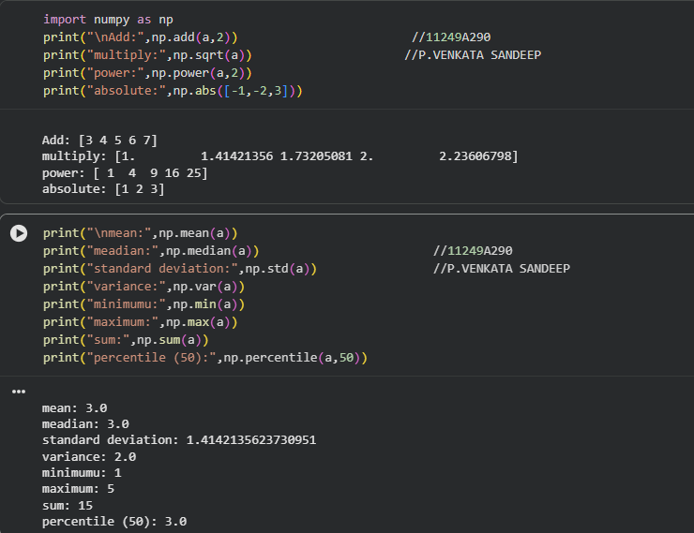

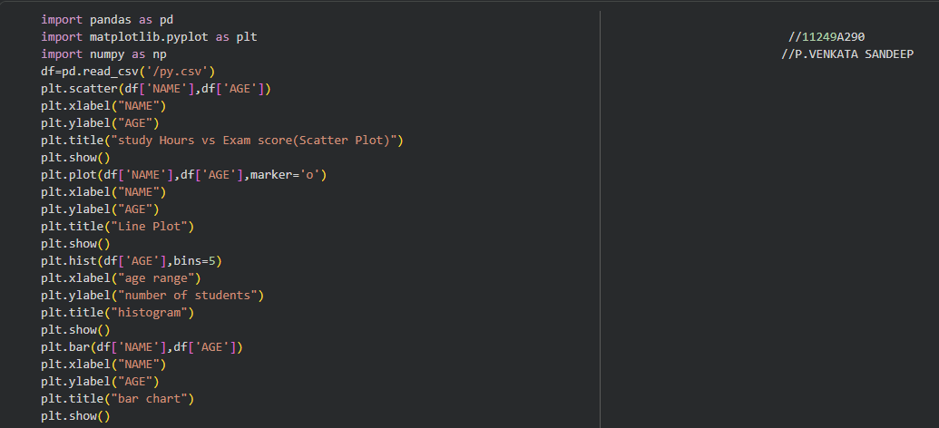

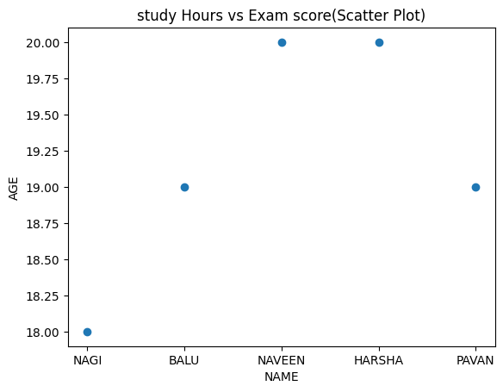
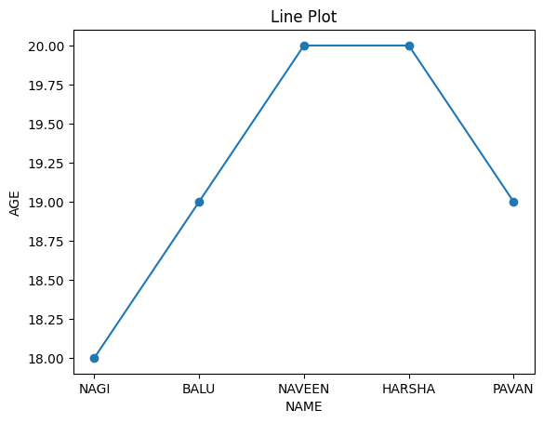
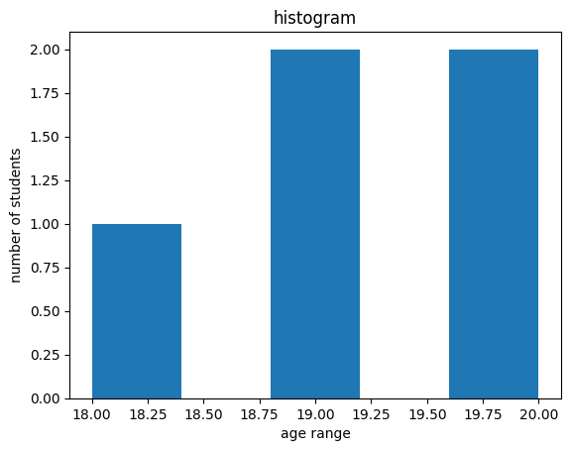
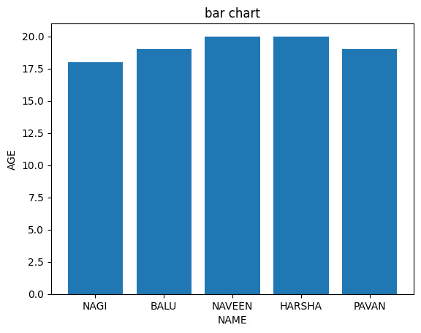

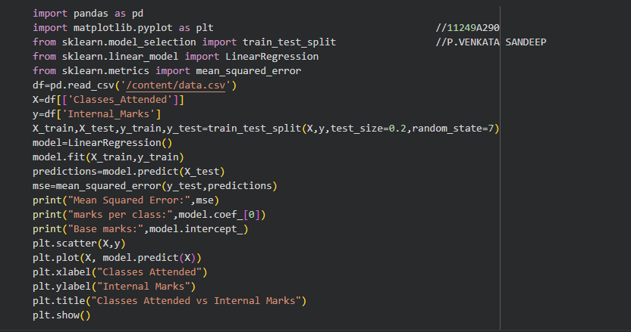

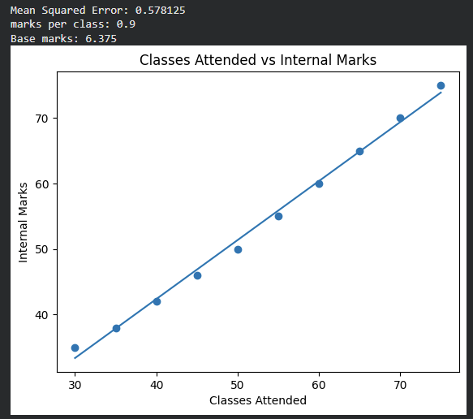

Result: Basic operations using these libraries were performed successfully.

Ex No:02 Date:12-02-26

Perform Data exploration and preprocessing in Python

Aim:To perform data exploration and preprocessing in Python.

Program:

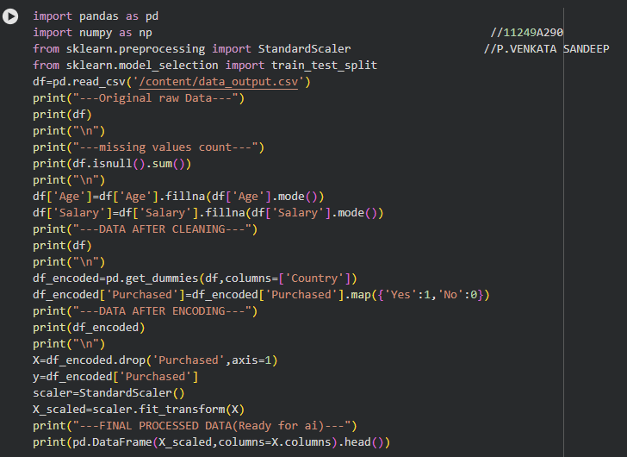

Output:

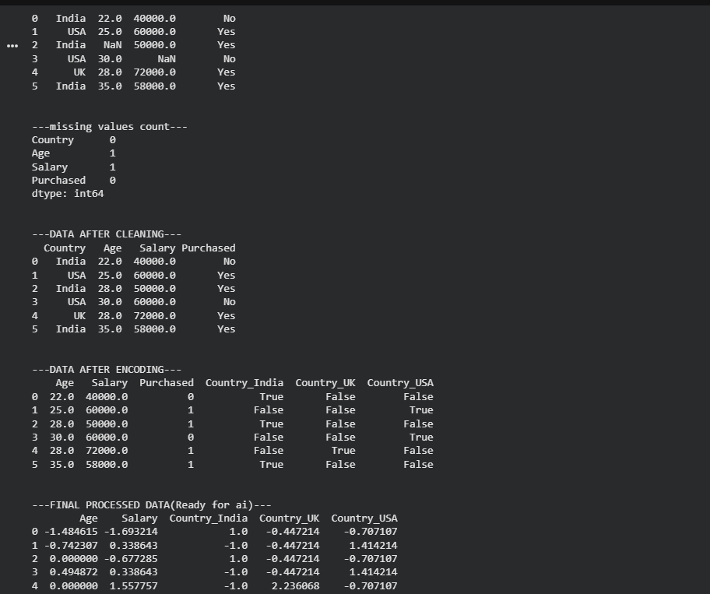

Result:Data was explored and preprocessed successfully using Python.

Ex No:03 Date:19-02-26

Implement regularised Linear regression

Aim:To implement regularized linear regression to improve model performance and control overfitting.

Program:

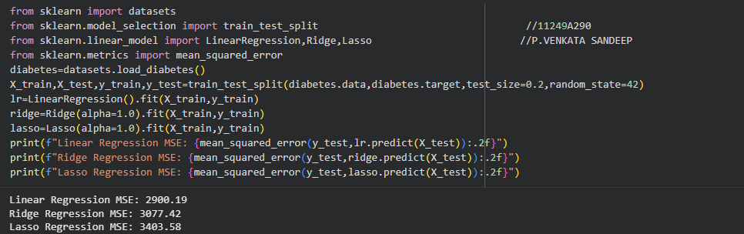

Result:The model was successfully implemented, and regularization helped reduce overfitting and improved prediction accuracy.

Ex No:04 Date:05-02-26

Implement Naive Bayes classifier for dataset stored as CSV file

Aim:
To implement the Naive Bayes classifier using a dataset stored in a CSV file for classification.

Program:
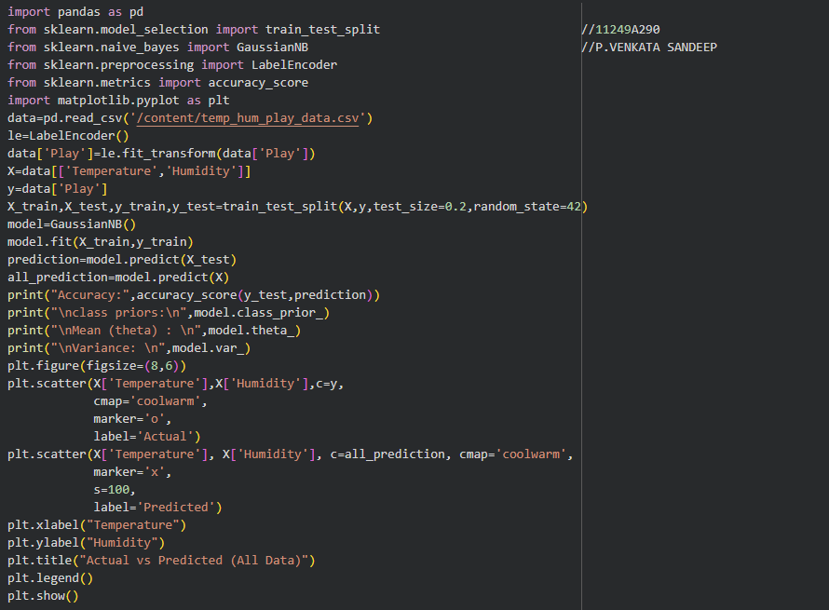

Output:

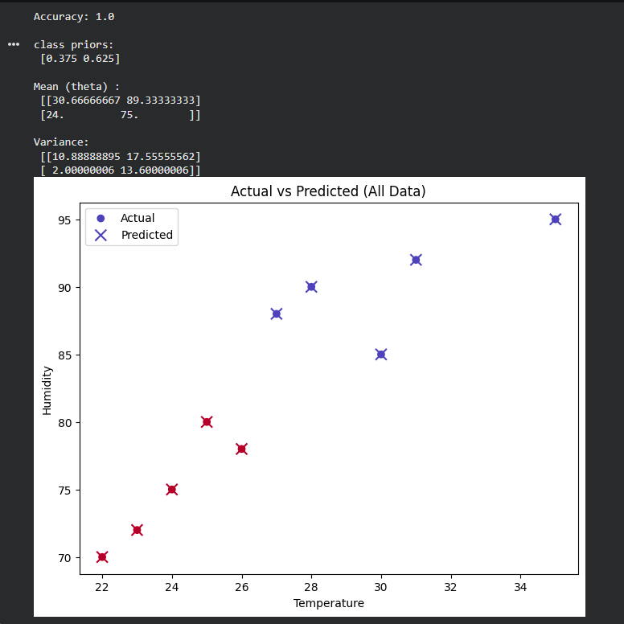

Result:
The Naive Bayes model was successfully implemented, and it effectively classified the data with good accuracy.

Ex No:05 Date:05-03-26

Implement regularized logistic regression

Aim:
To implement regularized logistic regression for classification while reducing overfitting.

Program:

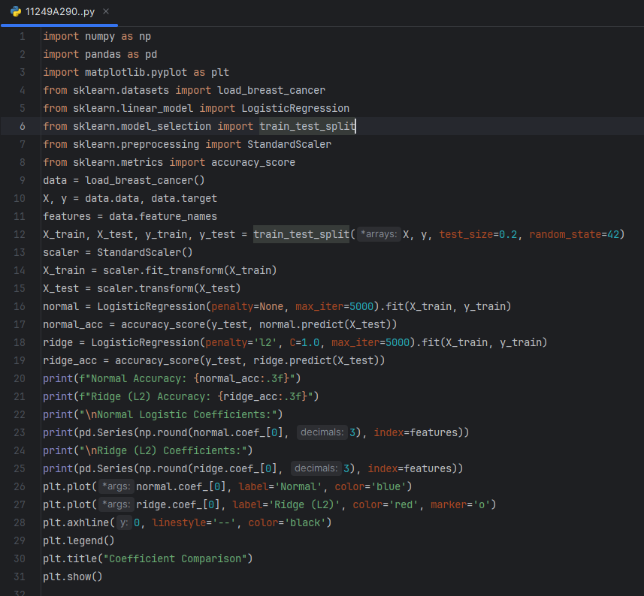

Output:

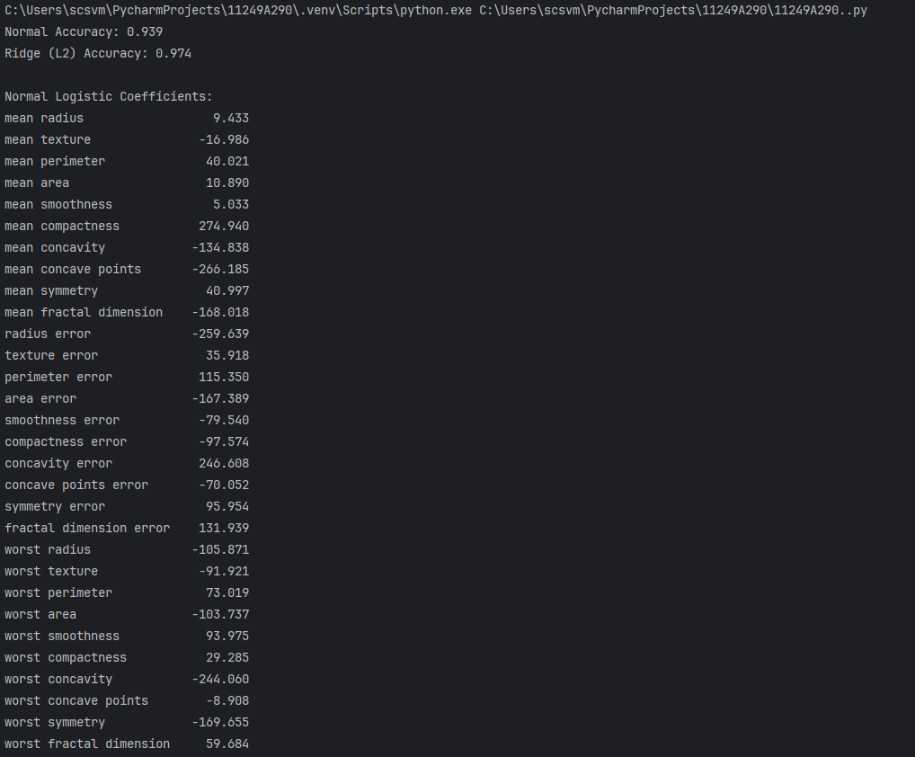

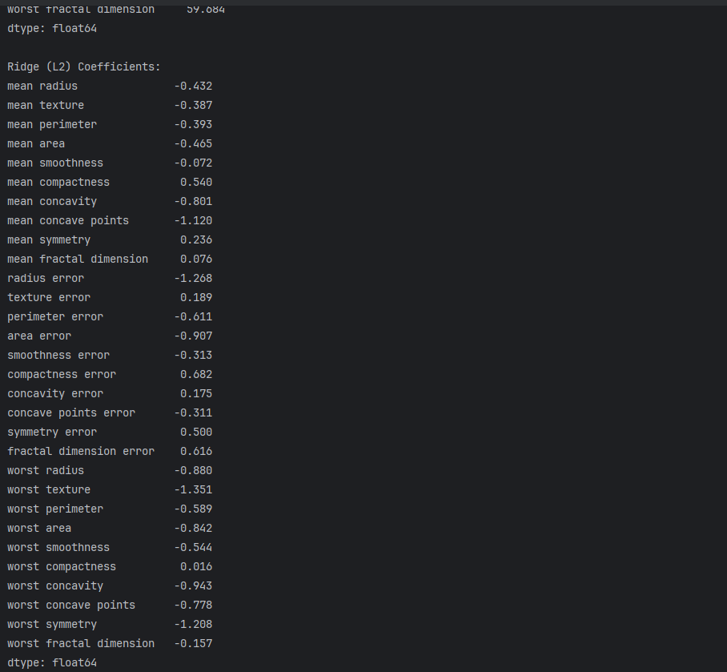
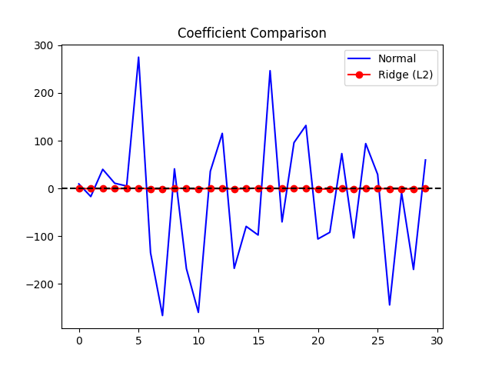

Result:
The model was successfully implemented, and regularization improved accuracy and prevented overfitting.

Ex No:06 Date:12-03-26

Build models using different Ensembling techniques
Aim:
To build models using different ensembling techniques to improve prediction performance

Program:
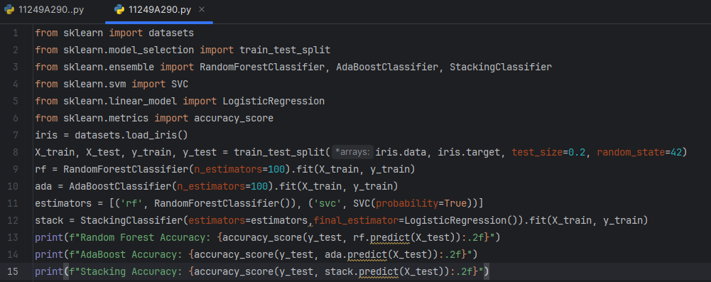

Output:
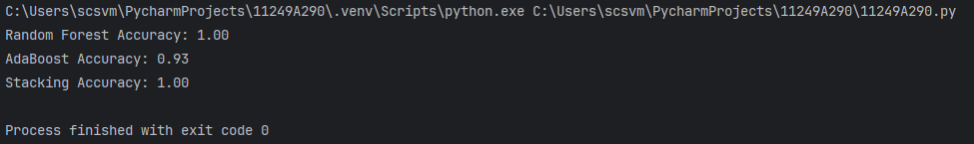

Result:
The ensemble models were successfully implemented, and they provided better accuracy compared to individual models.

Ex No:07 Date:12-03-26

Build models using Decision trees

Aim:
To build a model using Decision Trees for classification or prediction.

Program:
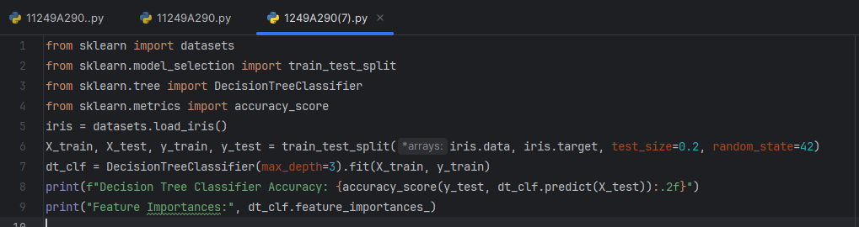
Output:
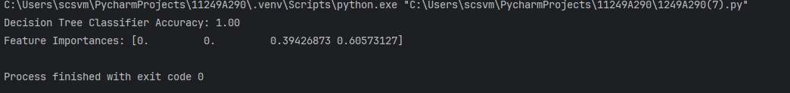

Result:
The Decision Tree model was successfully implemented and provided good prediction performance.

Ex No:08 Date:02-04-26

Build model using SVM with different kernels
Aim:
To build an SVM model using different kernel functions for classification.

Program:
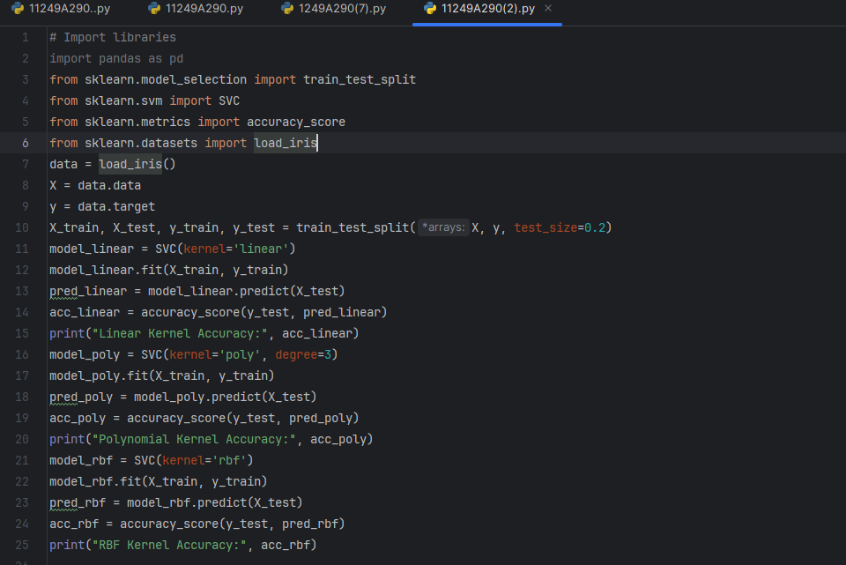
Output:
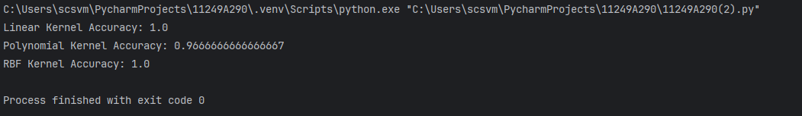
Result:
The SVM models were successfully implemented with various kernels, and they achieved good classification performance.

Ex No:09 Date:02-04-26

Implement K-NN algorithm to classify a dataset

Aim:To implement the K-Nearest Neighbors (K-NN) algorithm to classify a dataset
Program:
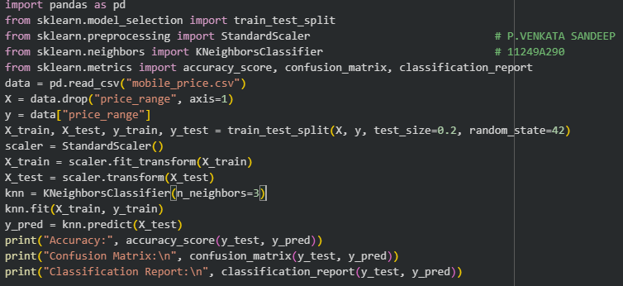
Output:
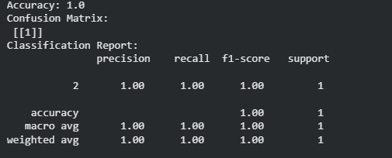

Result:
The K-NN model was successfully implemented and it classified the dataset with good accuracy

Ex No:10 Date:02-04-26

Build model to perform Clustering using K-means
after applying PCA and determining

Aim:
To build a clustering model using K-Means after applying PCA for dimensionality reduction and determining optimal clusters.

Program:
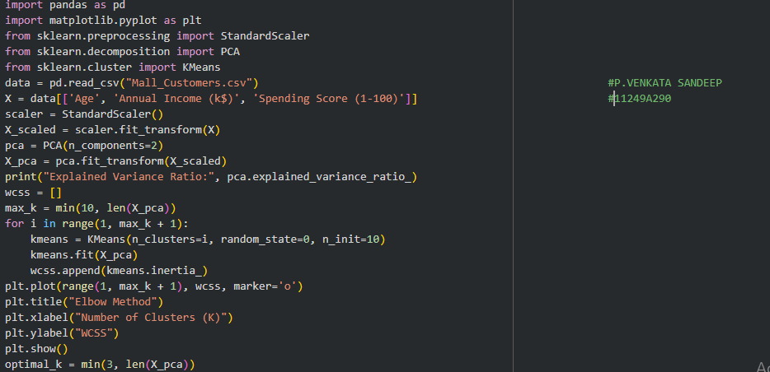
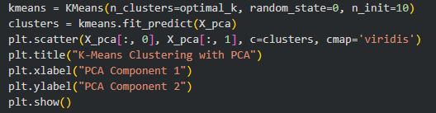

Output:
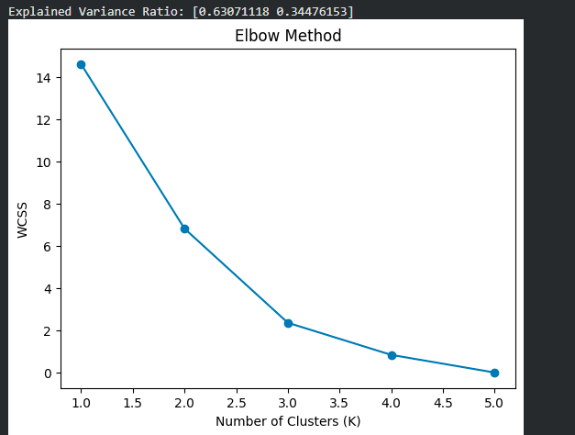

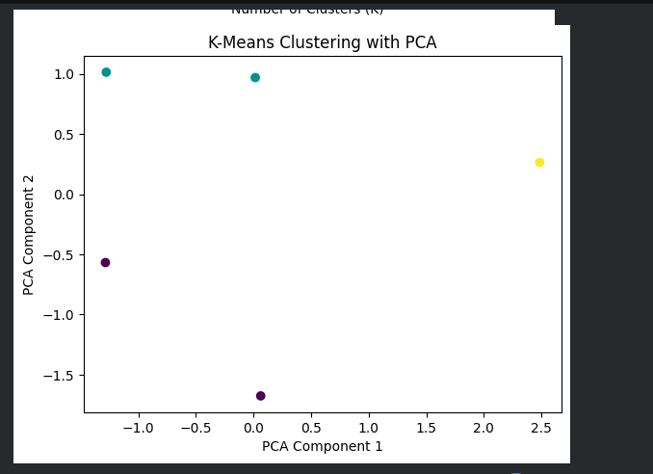

Result:
The K-Means clustering model was successfully implemented after PCA, and the data was grouped effectively into clusters

